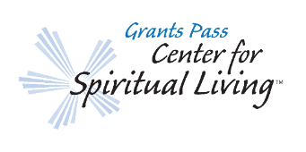
Rev. Steven Van Meter
Grants Pass Center for Spiritual Living
Ministers Report: Wednesday, 12.13.2023 Prayer @ 11:00AM
WELCOME! NEW SECRETARY, ROXANNE ZIRKEL
- WENDY ORSATT: PROPOSAL PROCEDURE. DISCUSSION.
- NEW MEMBERSHIP DIRECTORY? Discussion?
- COMMUNITY FORUM: DISCUSSION…
- YOUTH PROGRAM VISIONING: January 9, 2024 at 1:00 PM
- Nancy Yonally’s Proposal? (Should we invite Nancy to explain? Jeanette, Nedra and Nola Brech?)
- Samantha Hall Proposal? Soul Collage.
- NEW MEMBERS CERTIFICATES/ORIENTATION/NEW MEMBER SUNDAY AND VIDEO:

New Member Orientation January 14, 2024 (Jamica to video…?).
New Member Sunday January 21, 2024. Announce new members and give out certificates.

- HOLIDAY PARTY THIS FRIDAY, DECEMBER 15TH AT 5PM:
Bucky and Paula are facilitating our Holiday party this year. THIS IS A FREE EVENT! Optional $20 gift exchange.

- Free Foundations Class Starts Friday, January 5, 2024 from 1-4PM: Trazia Wylie will assist.

- BUILDING AND GROUNDS:
- Our front door still needs to be repainted. Waiting till spring.
- LEC Leak near office entrance. Discussion?

BAND REHEARSAL SPACE…THANK YOU!
Thank you for letting us use the stage to rehearse. We had planned a concert for Dec. 31, 2023, but are not ready yet. We are planning a concert for some time in January or February 2024.
Next GPCSL Board of Trustees Meeting Date? :
END OF MINISTERIAL REPORT

