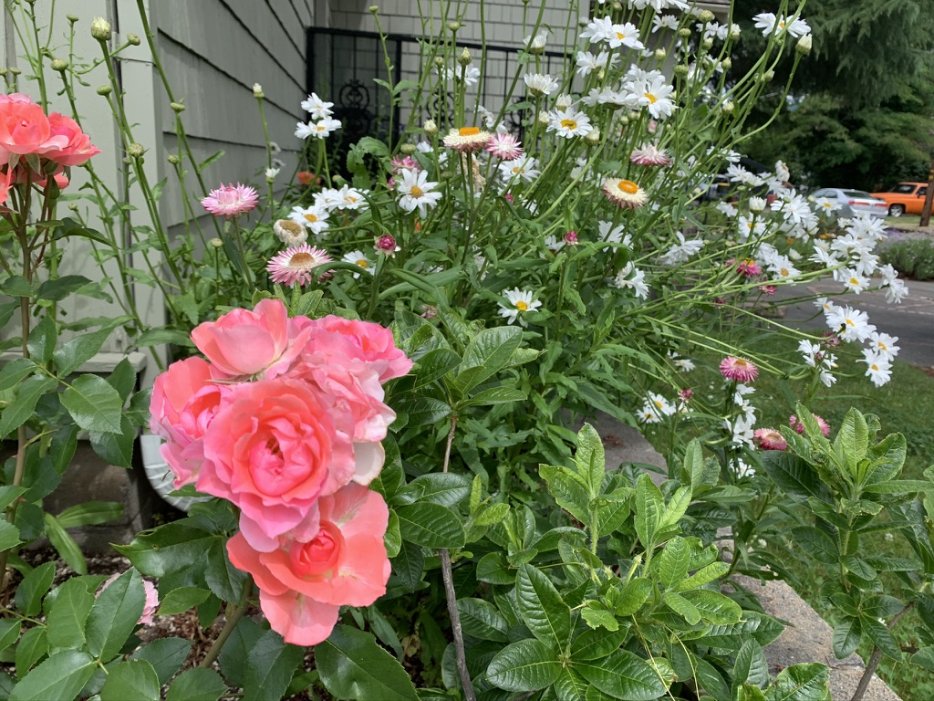

GRANTS PASS CENTER
FOR SPIRITUAL LIVING

MEMBER BIO FORM

The GPCSL Historical Committee invites you to complete the member biography form below. We are documenting our current and past members so that we can create a colorful narrative about our center. We want to enrich our story by documenting the beautiful people who make up our center.

Name

When or approximately when did you begin attending GPCSL

What groups or activities have you been a part of? (For example: Spiritual Gardeners, Kitchen Angels, Choir, Classes)

What would you like to be involved in going forward?

What are your favorite memories at GPCSL?

In one sentence, describe what you love most about GPCSL

Use just three words to describe how you feel about GPCSL

1:

2:

3:

